Students open and turn files in through Kami
The students can open the file directly from Classroom into Kami. Students have the Google Chrome extension installed, they can open the file into Kami directly from the preview window.
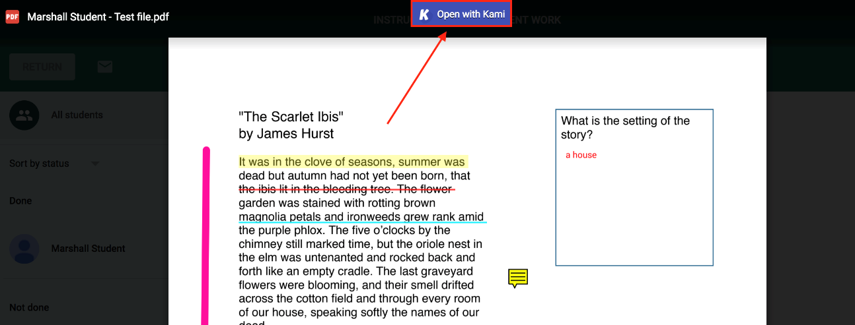
After opening the file, the student can turn in the assignment directly into Classroom from Kami.
To turn in the file, the student can click the "Save" button in the top right corner and then select Turn In. This will force save the student's annotations and turn in the assignment into Google Classroom.
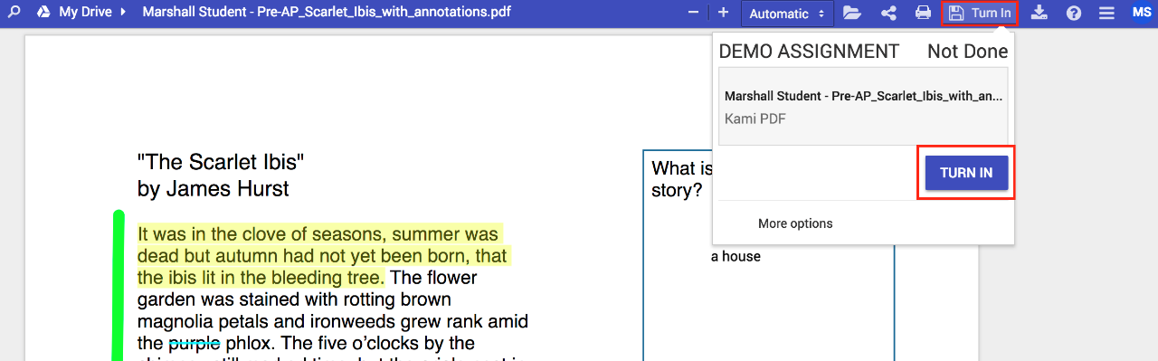

The main advantage of this feature is that it cuts down the steps needed to turn an assignment in. For example, students no longer need to manually save their annotations or worry about Kami's dual saving system.

